Lucas Swanson
5/03/2025
Software Engineering Methods
Exercise 5.4 (Individual Code Review)

DeleteRound – roundMode.js
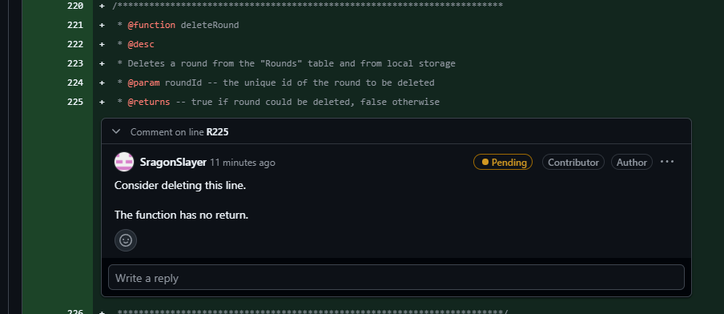
confirmDelete – roundMode.js
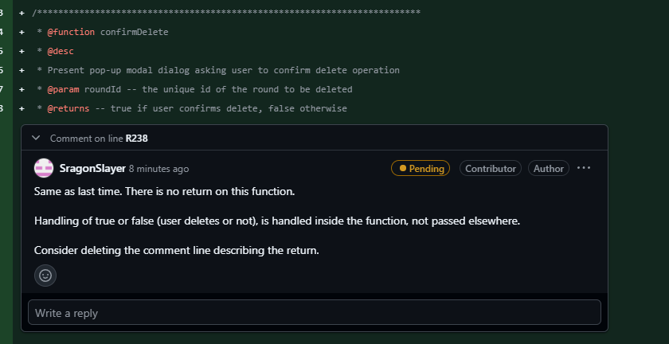
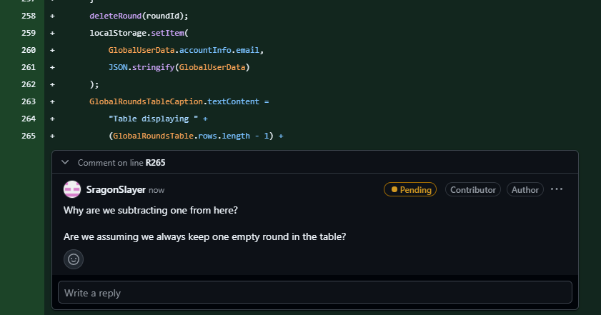
Index.html
